Book Signing
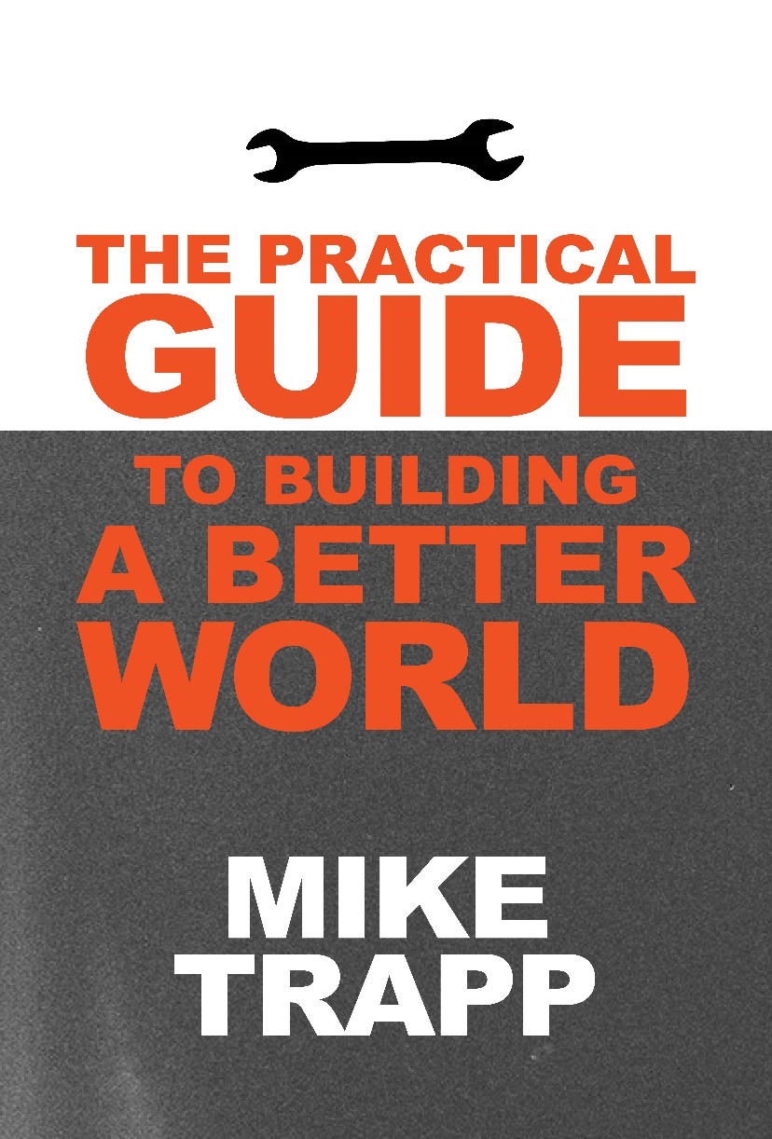
Sunday July, 20th 5pm to 7pm
Cooper’s Landing
11505 Smith Hatchery Road
“Mike Trapp's experiences are many and varied, and the lessons learned from them are important to us all. Dip into any page of this book and you'll find something useful to carry away." —Steve Wiegenstein, author of Land of Joys
For more info https://miketrapp.store

